Inset Days and Staff meetings
2023/24

Inset Days & Staff Meetings

Overview
ECM can provide and arrange all your INSET Day and Staff Meeting needs. Choose from our full offer of CPD topics or request a bespoke INSET or Staff Meeting delivery. INSET and Staff Meetings can be delivered to small and larger groups, with clusters of schools joining up for shared CPD. As demand is usually around the same time as many other schools, it is advisable to book well in advance to ensure your booking and needs can be met.
Some of our most popular INSET Day and Staff Meeting topics:
Ensure your subject curriculum intent is high quality and will stand up to inspection scrutiny
Deep Dives in all subjects
Giving strong account in your subject
Outstanding Subject Leadership 1: Role of the subject leader in the Inspection Framework
Outstanding Subject Leadership 2: Securing robust subject Self-Evaluation and developing planning in the Inspection Framework - Establishing a clear vision and strategic direction for your subject in the coming year through rigorous self-evaluation and strategic planning
Outstanding Subject Leadership 3: Monitoring, coaching and mentoring in your subject in the NEW Inspection Framework - Developing systematic, efficient and highly effective systems for monitoring in your subject. The "how" of coaching, mentoring and feedback to secure the best learning, teaching and pupil outcomes in your subject.
Outstanding Subject Leadership 4: Improving outcomes in your subject through Training, Coaching, Modelling and Mentoring
Metacognition - Developing learner independence to secure better / improved outcomes.
Teaching to improve memory, building knowledge using cognitive load theory - practical solutions for subject leaders and class teachers
Further details and other session titles can be found on our website.

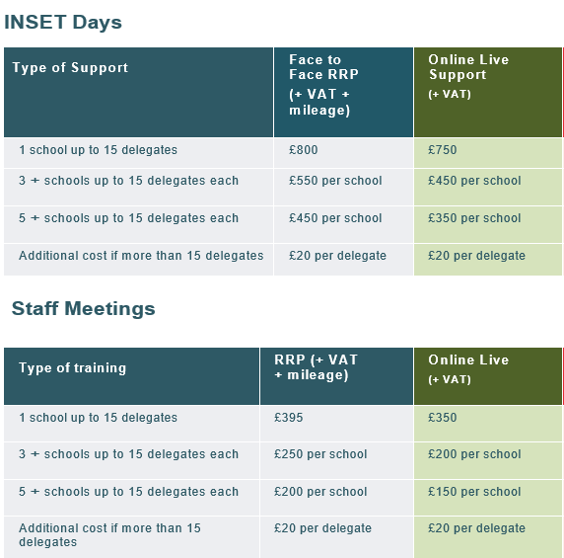
Please contact us (contact details below) for further information or to request an Inset Day.

